I want to use 3 free late days for this assignment.

4.1: 'MatchThreshold', 10

'MaxRatio', 0.68

4.2:

The BRIEF will not work when the image rotates, this may because BRIEF uses detectFASTFeatures function that is not able to detect features from two rotated images. After using SURF, the plot changes significantly, SURF handles rotated images much better than BRIEF. Following are some examples.

BRIEF rotate 30 degrees

SURF rotate 30 degrees

BRIEF rotate 100 degrees

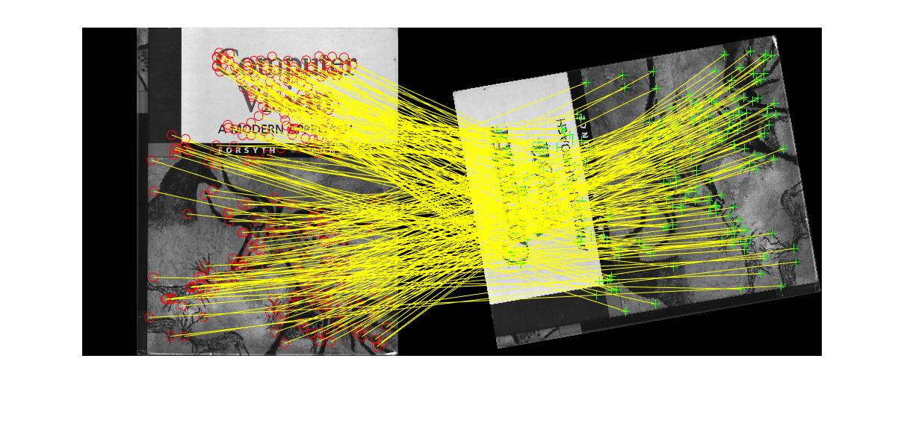

SURF rotate 100 degrees

BRIEF rotate 200 degrees

SURF rotate 200 degrees

4.4: generated by visualize.m (compute_norm)

4.5: generated by visualize.m (compute_ransac)

4.6:

